**Data:**

Hours,Scores

2.5,21

5.1,47

3.2,27

8.5,75

3.5,30

1.5,20

9.2,88

5.5,60

8.3,81

2.7,25

7.7,85

5.9,62

4.5,41

3.3,42

1.1,17

8.9,95

2.5,30

1.9,24

6.1,67

7.4,69

2.7,30

4.8,54

3.8,35

6.9,76

7.8,86

**Q: What will be the predicted score if a student studies for 9.25hrs/day?**

**Ans: Using SPSS, we got the following output.**

**Linear Regression:**

|  |  |  |  |
| --- | --- | --- | --- |
| **Descriptive Statistics** | | | |
|  | Mean | Std. Deviation | N |
| score | 51.48 | 25.287 | 25 |
| hours | 5.01 | 2.525 | 25 |

|  |  |  |  |
| --- | --- | --- | --- |
| **Correlations** | | | |
|  | | score | hours |
| Pearson Correlation | score | 1.000 | .976 |
| hours | .976 | 1.000 |
| Sig. (1-tailed) | score | . | .000 |
| hours | .000 | . |
| N | score | 25 | 25 |
| hours | 25 | 25 |

|  |  |  |  |
| --- | --- | --- | --- |
| **Variables Entered/Removeda** | | | |
| Model | Variables Entered | Variables Removed | Method |
| 1 | hoursb | . | Enter |
| a. Dependent Variable: score | | | |
| b. All requested variables entered. | | | |

|  |  |  |  |  |
| --- | --- | --- | --- | --- |
| **Model Summaryb** | | | | |
| Model | R | R Square | Adjusted R Square | Std. Error of the Estimate |
| 1 | .976a | .953 | .951 | 5.603 |
| a. Predictors: (Constant), hours | | | | |
| b. Dependent Variable: score | | | | |

**Regression**

|  |  |  |  |  |  |  |
| --- | --- | --- | --- | --- | --- | --- |
| **ANOVAa** | | | | | | |
| Model | | Sum of Squares | df | Mean Square | F | Sig. |
| 1 | Regression | 14624.172 | 1 | 14624.172 | 465.823 | .000b |
| Residual | 722.068 | 23 | 31.394 |  |  |
| Total | 15346.240 | 24 |  |  |  |
| a. Dependent Variable: score | | | | | | |
| b. Predictors: (Constant), hours | | | | | | |

|  |  |  |  |  |  |  |  |  |
| --- | --- | --- | --- | --- | --- | --- | --- | --- |
| **Coefficientsa** | | | | | | | | |
| Model | | Unstandardized Coefficients | | Standardized Coefficients | t | Sig. | 95.0% Confidence Interval for B | |
| B | Std. Error | Beta | Lower Bound | Upper Bound |
| 1 | (Constant) | 2.484 | 2.532 |  | .981 | .337 | -2.753 | 7.721 |
| hours | 9.776 | .453 | .976 | 21.583 | .000 | 8.839 | 10.713 |
| a. Dependent Variable: score | | | | | | | | |

|  |  |  |  |  |  |
| --- | --- | --- | --- | --- | --- |
| **Residuals Statisticsa** | | | | | |
|  | Minimum | Maximum | Mean | Std. Deviation | N |
| Predicted Value | 13.24 | 92.42 | 51.48 | 24.685 | 25 |
| Residual | -10.578 | 7.265 | .000 | 5.485 | 25 |
| Std. Predicted Value | -1.549 | 1.659 | .000 | 1.000 | 25 |
| Std. Residual | -1.888 | 1.297 | .000 | .979 | 25 |
| a. Dependent Variable: score | | | | | |

**Charts**

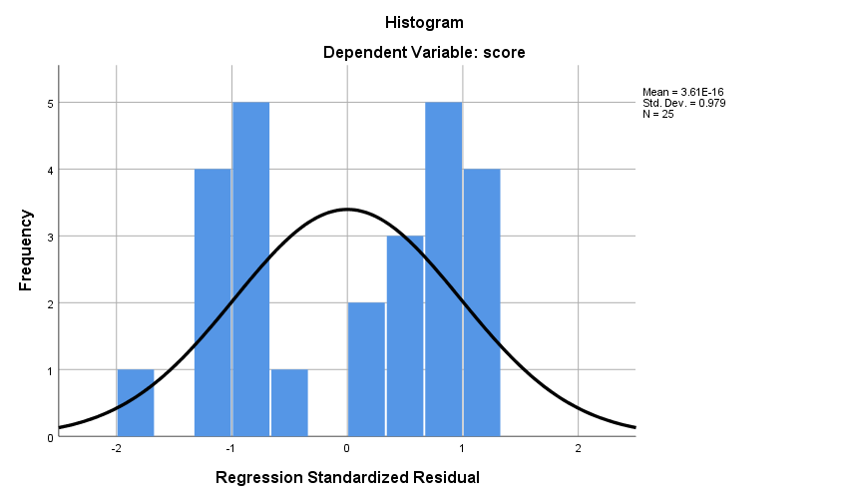

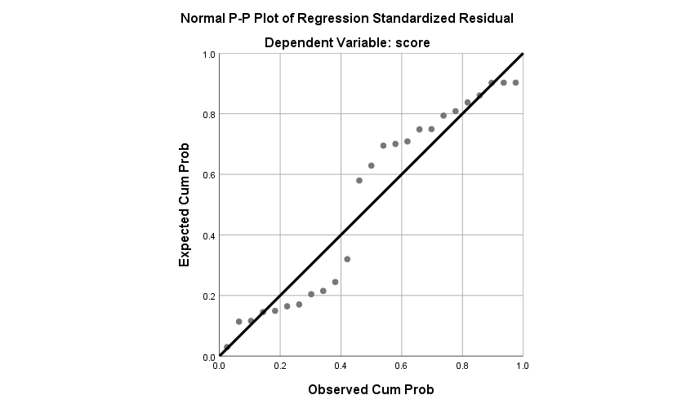

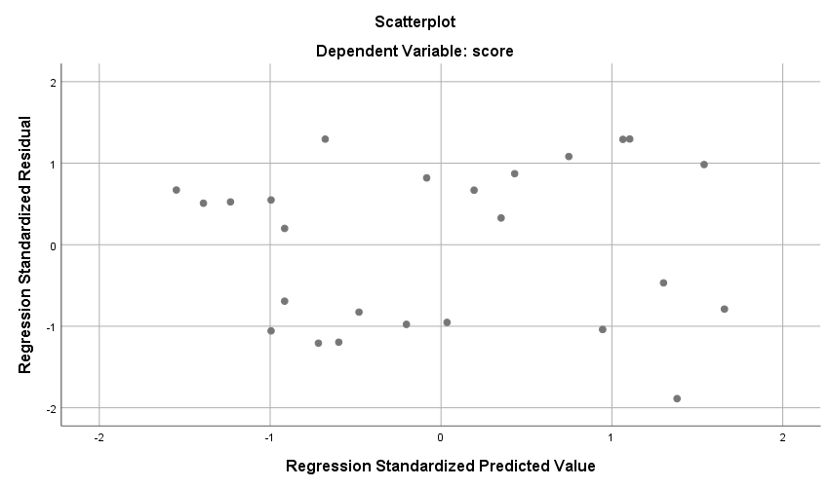

**Conclusion:**

From the above analysis we got the values of intercept (b0) and slope/coefficient (b1).

(b0)=**2.484**, (b1) =**9.776**

Now using the equation of regression,

**Y=b0+b1(x)**

Score=2.484+9.776*9.25

Score=92.912 = 93(approx)

Therefore, if a student studies for **9.25 hours**, he will get a score of **92.912**.